**Week 2- PL SQL Programming- Hands-On Exercises**

**Exercise 1: Control Structures**

**Scenario 1:** The bank wants to apply a discount to loan interest rates for customers above 60 years old.

**Query:**

DECLARE

TYPE customer_record IS RECORD (

customer_id NUMBER,

name VARCHAR2(100),

age NUMBER,

loan_interest_rate NUMBER

);

TYPE customer_table IS TABLE OF customer_record;

customers customer_table;

new_customer_id NUMBER;

new_name VARCHAR2(100);

new_age NUMBER;

new_loan_interest_rate NUMBER;

BEGIN

customers := customer_table(

customer_record(1, 'Hema Srivalli', 65, 5.00),

customer_record(2, 'Pratyusha', 58, 4.50),

customer_record(3, 'Jyothsna', 72, 6.00),

customer_record(4, 'Siddhi', 45, 3.75),

customer_record(5, 'Dolly', 62, 5.25)

);

FOR i IN 1 .. customers.COUNT LOOP

new_customer_id := customers(i).customer_id;

new_name := customers(i).name;

new_age := customers(i).age;

new_loan_interest_rate := customers(i).loan_interest_rate;

IF new_age > 60 THEN

new_loan_interest_rate := new_loan_interest_rate * 0.99;

DBMS_OUTPUT.PUT_LINE('Updated customer ID: ' || new_customer_id ||

', Name: ' || new_name ||

', Age: ' || new_age ||

' - New interest rate: ' || new_loan_interest_rate);

END IF;

END LOOP;

EXCEPTION

WHEN OTHERS THEN

DBMS_OUTPUT.PUT_LINE('An error occurred: ' || SQLERRM);

END;

/

**Output:**

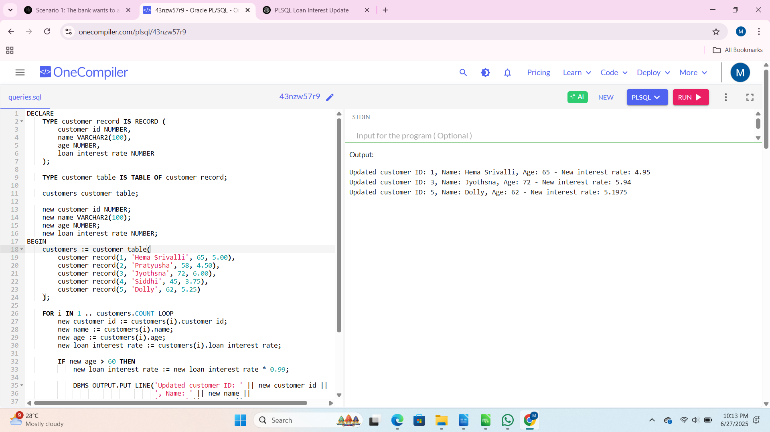  
  
**Scenario 2:** A customer can be promoted to VIP status based on their balance.

Question: Write a PL/SQL block that iterates through all customers and sets a flag IsVIP to TRUE for those with a balance over $10,000.

**Query:**

DECLARE

TYPE customer_type IS RECORD (

customer_id NUMBER,

name VARCHAR2(100),

balance NUMBER,

is_vip BOOLEAN

);

TYPE customer_table IS TABLE OF customer_type;

customers customer_table := customer_table(

customer_type(1, 'Siddhi', 7500, FALSE),

customer_type(2, 'Pavan', 12000, FALSE),

customer_type(3, 'Pratyusha', 9000, FALSE),

customer_type(4, 'Jyothsna', 25000, FALSE),

customer_type(5, 'Dolly', 8000, FALSE)

);

vip_threshold CONSTANT NUMBER := 10000;

BEGIN

DBMS_OUTPUT.PUT_LINE('VIP Promotion Processing');

DBMS_OUTPUT.PUT_LINE('------------------------');

FOR i IN 1..customers.COUNT LOOP

IF customers(i).balance > vip_threshold THEN

customers(i).is_vip := TRUE;

DBMS_OUTPUT.PUT_LINE('Promoted to VIP: ' || customers(i).name ||

' (Balance: $' || customers(i).balance || ')');

ELSE

DBMS_OUTPUT.PUT_LINE('Not qualified: ' || customers(i).name ||

' (Balance: $' || customers(i).balance || ')');

END IF;

END LOOP;

DBMS_OUTPUT.PUT_LINE(CHR(10) || 'Final VIP Status:');

DBMS_OUTPUT.PUT_LINE('-----------------');

FOR i IN 1..customers.COUNT LOOP

DBMS_OUTPUT.PUT_LINE(

RPAD(customers(i).name, 15) || ' | ' ||

RPAD('$' || customers(i).balance, 10) || ' | ' ||

CASE WHEN customers(i).is_vip THEN 'VIP' ELSE 'Regular' END

);

END LOOP;

EXCEPTION

WHEN OTHERS THEN

DBMS_OUTPUT.PUT_LINE('Error: ' || SQLERRM);

END;

/

**Output:**

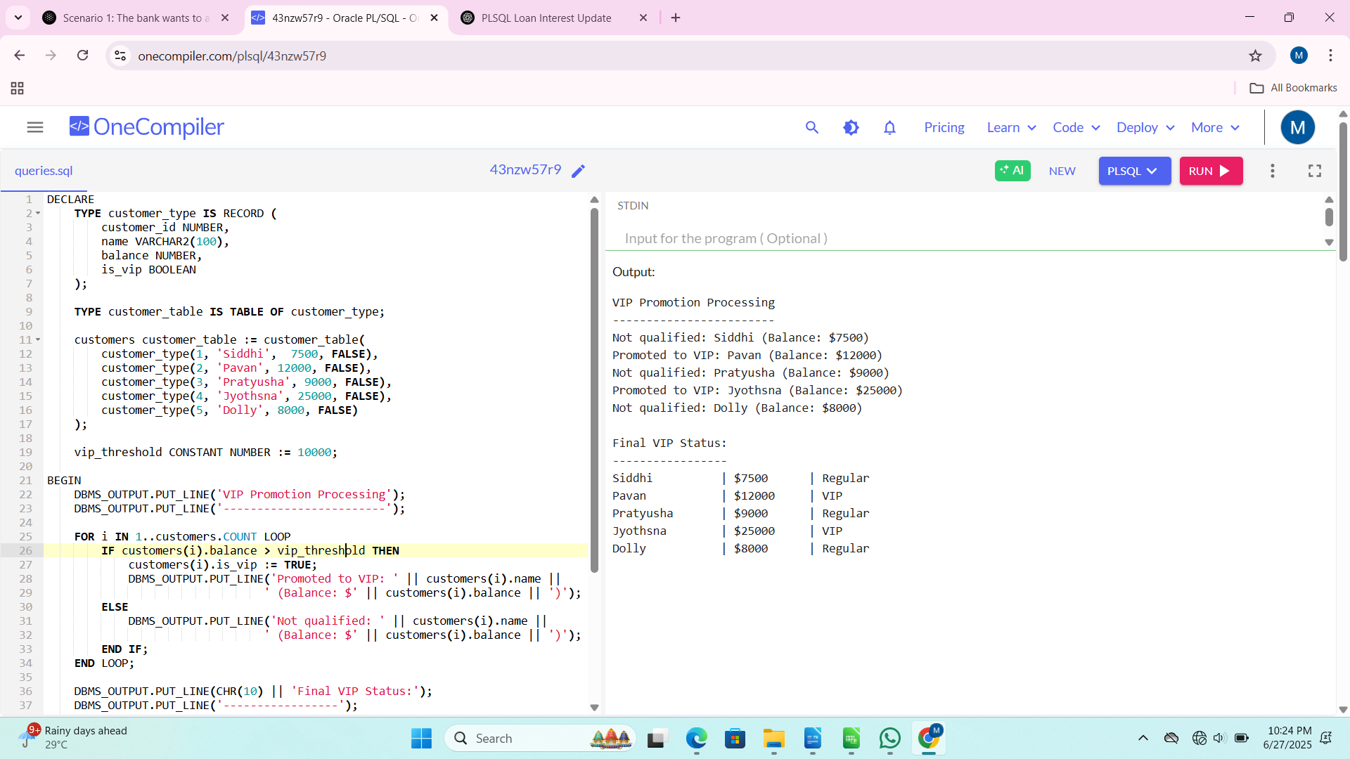 **Scenario 3:** The bank wants to send reminders to customers whose loans are due within the next 30 days.

**Query:**

DECLARE

TYPE loan_type IS RECORD (

loan_id NUMBER,

customer_name VARCHAR2(100),

due_date DATE,

amount NUMBER,

is_reminder_sent BOOLEAN

);

TYPE loan_table IS TABLE OF loan_type;

loans loan_table := loan_table(

loan_type(101, 'Anuhya', SYSDATE + 15, 5000, FALSE),

loan_type(102, 'Anitha', SYSDATE + 60, 7500, FALSE),

loan_type(103, 'Usha', SYSDATE + 5, 12000, FALSE),

loan_type(104, 'Akshitha', SYSDATE + 28, 8000, FALSE),

loan_type(105, 'Satyavathi', SYSDATE + 31, 3000, FALSE)

);

c_reminder_days CONSTANT NUMBER := 30;

BEGIN

DBMS_OUTPUT.PUT_LINE('LOAN REMINDER PROCESSING');

DBMS_OUTPUT.PUT_LINE('------------------------');

FOR i IN 1..loans.COUNT LOOP

IF loans(i).due_date <= SYSDATE + c_reminder_days THEN

loans(i).is_reminder_sent := TRUE;

DBMS_OUTPUT.PUT_LINE('REMINDER: ' || loans(i).customer_name ||

CHR(10) || 'Loan ID: ' || loans(i).loan_id ||

CHR(10) || 'Amount Due: $' || loans(i).amount ||

CHR(10) || 'Due Date: ' || TO_CHAR(loans(i).due_date, 'DD-MON-YYYY') ||

CHR(10) || 'Days Remaining: ' || (loans(i).due_date - SYSDATE) ||

CHR(10) || '-----------------------------------');

END IF;

END LOOP;

DBMS_OUTPUT.PUT_LINE(CHR(10) || 'REMINDER SUMMARY');

DBMS_OUTPUT.PUT_LINE('----------------');

FOR i IN 1..loans.COUNT LOOP

DBMS_OUTPUT.PUT_LINE(

RPAD(loans(i).customer_name, 20) || ' | ' ||

RPAD('#' || loans(i).loan_id, 10) || ' | ' ||

RPAD(TO_CHAR(loans(i).due_date, 'DD-MON'), 10) || ' | ' ||

CASE WHEN loans(i).is_reminder_sent THEN 'REMINDER SENT' ELSE 'Not due soon' END

);

END LOOP;

EXCEPTION

WHEN OTHERS THEN

DBMS_OUTPUT.PUT_LINE('Error processing reminders: ' || SQLERRM);

END;

/

**Output:**

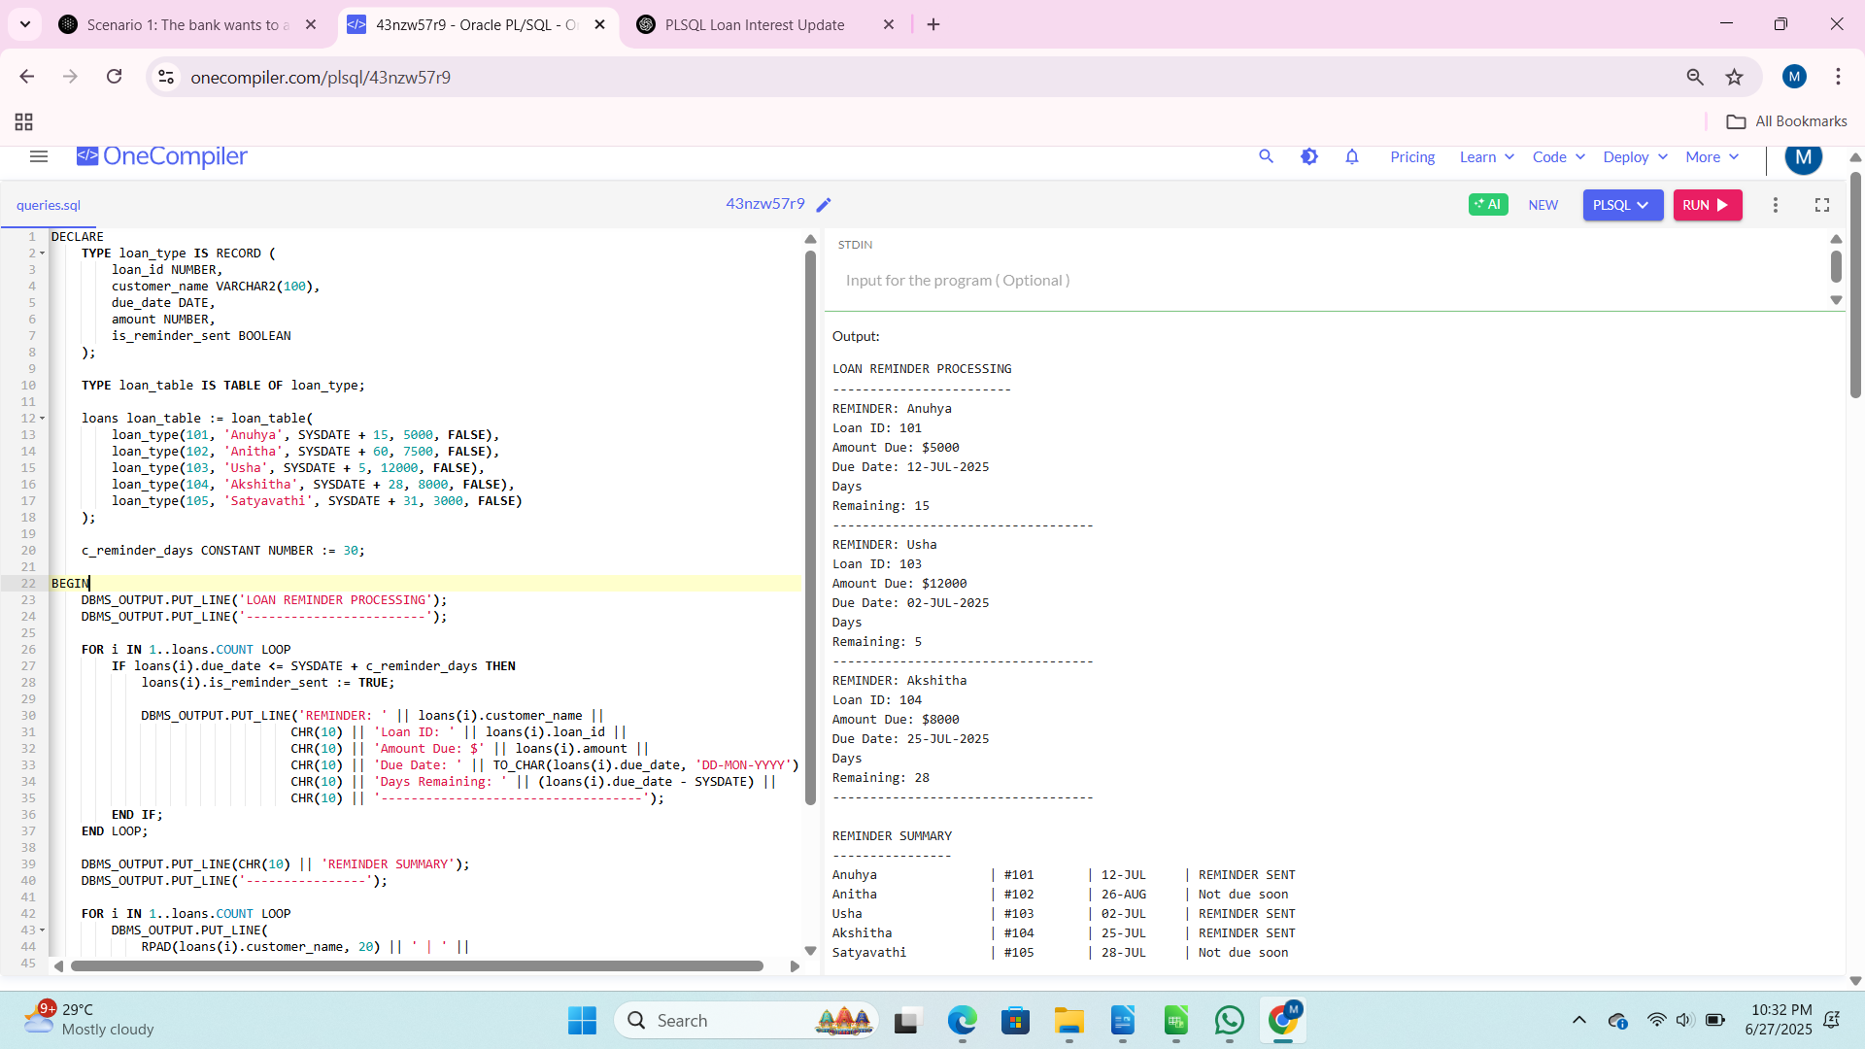 **Exercise 3: Stored Procedures**

**Scenario 1:** The bank needs to process monthly interest for all savings accounts.

**Query:**

DECLARE

TYPE AccountRecord IS RECORD (

account_id NUMBER,

account_holder VARCHAR2(100),

balance NUMBER(10, 2),

last_interest_date DATE

);

TYPE AccountTable IS TABLE OF AccountRecord INDEX BY PLS_INTEGER;

accounts AccountTable;

PROCEDURE ProcessMonthlyInterest IS

v_interest_rate CONSTANT NUMBER := 0.01;

BEGIN

FOR i IN 1 .. accounts.COUNT LOOP

accounts(i).balance := accounts(i).balance * (1 + v_interest_rate);

accounts(i).last_interest_date := SYSDATE;

END LOOP;

DBMS_OUTPUT.PUT_LINE('Applied 1% interest to all savings accounts.');

END ProcessMonthlyInterest;

BEGIN

accounts(1) := AccountRecord(1, 'Siddhi, 5000.00, NULL);

accounts(2) := AccountRecord(2, 'Hema', 10000.00, NULL);

accounts(3) := AccountRecord(3, 'Pavan', 7500.00, NULL);

DBMS_OUTPUT.PUT_LINE('=== Initial Balances ===');

FOR i IN 1 .. accounts.COUNT LOOP

DBMS_OUTPUT.PUT_LINE(

RPAD(accounts(i).account_holder, 15) || ': $' ||

TO_CHAR(accounts(i).balance, '999,990.00')

);

END LOOP;

ProcessMonthlyInterest();

DBMS_OUTPUT.PUT_LINE('=== Balances After Interest ===');

FOR i IN 1 .. accounts.COUNT LOOP

DBMS_OUTPUT.PUT_LINE(

RPAD(accounts(i).account_holder, 15) || ': $' ||

TO_CHAR(accounts(i).balance, '999,990.00')

);

END LOOP;

END;

/

**Output:**

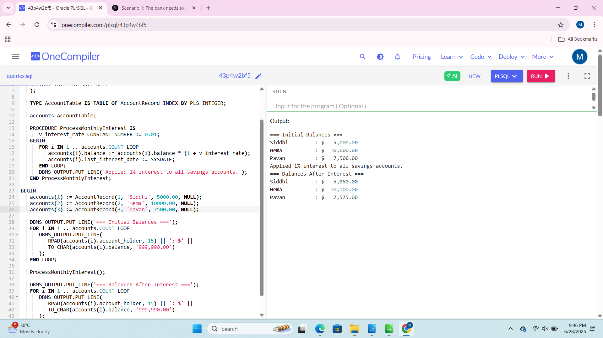 **Scenario 2:** The bank wants to implement a bonus scheme for employees based on their performance.

**Query:**

DECLARE

TYPE EmployeeRecord IS RECORD (

employee_id NUMBER,

employee_name VARCHAR2(100),

department VARCHAR2(50),

salary NUMBER(10, 2),

bonus_percentage NUMBER(5, 2),

updated_salary NUMBER(10, 2)

);

TYPE EmployeeTable IS TABLE OF EmployeeRecord INDEX BY PLS_INTEGER;

employees EmployeeTable;

PROCEDURE UpdateEmployeeBonus(

p_dept VARCHAR2,

p_bonus_percent NUMBER

) IS

BEGIN

DBMS_OUTPUT.PUT_LINE('Applying ' || p_bonus_percent || '% bonus to ' || p_dept || ' department');

FOR i IN 1..employees.COUNT LOOP

IF employees(i).department = p_dept THEN

employees(i).bonus_percentage := p_bonus_percent;

employees(i).updated_salary := employees(i).salary * (1 + p_bonus_percent/100);

DBMS_OUTPUT.PUT_LINE(' - ' || employees(i).employee_name ||

': ' || employees(i).salary || ' → ' ||

employees(i).updated_salary);

END IF;

END LOOP;

END UpdateEmployeeBonus;

BEGIN

employees(1) := EmployeeRecord(101, 'Mohini', 'Sales', 50000, 0, 50000);

employees(2) := EmployeeRecord(102, 'Sanvi', 'Sales', 55000, 0, 55000);

employees(3) := EmployeeRecord(103, 'Siddhi', 'IT', 60000, 0, 60000);

employees(4) := EmployeeRecord(104, 'Varun', 'HR', 45000, 0, 45000);

employees(5) := EmployeeRecord(105, 'Dolly', 'IT', 65000, 0, 65000);

DBMS_OUTPUT.PUT_LINE('=== Initial Salaries ===');

FOR i IN 1..employees.COUNT LOOP

DBMS_OUTPUT.PUT_LINE(

RPAD(employees(i).employee_name, 15) ||

RPAD(' (' || employees(i).department || ')', 10) ||

': $' || TO_CHAR(employees(i).salary, '999,990.00')

);

END LOOP;

UpdateEmployeeBonus('Sales', 10);

UpdateEmployeeBonus('IT', 5);

DBMS_OUTPUT.PUT_LINE('=== Updated Salaries ===');

FOR i IN 1..employees.COUNT LOOP

DBMS_OUTPUT.PUT_LINE(

RPAD(employees(i).employee_name, 15) ||

RPAD(' (' || employees(i).department || ')', 10) ||

': $' || TO_CHAR(employees(i).updated_salary, '999,990.00')

);

END LOOP;

END;

/

**Output:**

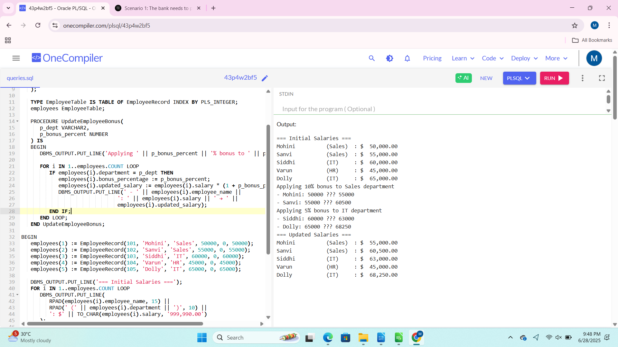 **Scenario 3:** Customers should be able to transfer funds between their accounts.

**Query:**

DECLARE

TYPE AccountRecord IS RECORD (

account_id NUMBER,

account_holder VARCHAR2(100),

balance NUMBER(10, 2)

);

TYPE AccountTable IS TABLE OF AccountRecord INDEX BY PLS_INTEGER;

accounts AccountTable;

PROCEDURE TransferFunds(

p_from_account_id NUMBER,

p_to_account_id NUMBER,

p_amount NUMBER

) IS

v_from_balance NUMBER;

v_to_balance NUMBER;

v_from_account_found BOOLEAN := FALSE;

v_to_account_found BOOLEAN := FALSE;

BEGIN

FOR i IN 1 .. accounts.COUNT LOOP

IF accounts(i).account_id = p_from_account_id THEN

v_from_balance := accounts(i).balance;

v_from_account_found := TRUE;

ELSIF accounts(i).account_id = p_to_account_id THEN

v_to_balance := accounts(i).balance;

v_to_account_found := TRUE;

END IF;

END LOOP;

IF NOT v_from_account_found THEN

DBMS_OUTPUT.PUT_LINE('Error: Source account not found.');

RETURN;

ELSIF NOT v_to_account_found THEN

DBMS_OUTPUT.PUT_LINE('Error: Destination account not found.');

RETURN;

END IF;

IF v_from_balance < p_amount THEN

DBMS_OUTPUT.PUT_LINE('Error: Insufficient balance in source account.');

RETURN;

END IF;

FOR i IN 1 .. accounts.COUNT LOOP

IF accounts(i).account_id = p_from_account_id THEN

accounts(i).balance := accounts(i).balance - p_amount;

ELSIF accounts(i).account_id = p_to_account_id THEN

accounts(i).balance := accounts(i).balance + p_amount;

END IF;

END LOOP;

DBMS_OUTPUT.PUT_LINE('Transfer successful: $' || p_amount ||

' transferred from account ' || p_from_account_id ||

' to account ' || p_to_account_id);

END TransferFunds;

BEGIN

accounts(1) := AccountRecord(101, 'Siddhi', 5000.00);

accounts(2) := AccountRecord(102, 'Mohith', 10000.00);

accounts(3) := AccountRecord(103, 'Pavan', 7500.00);

DBMS_OUTPUT.PUT_LINE('=== Initial Balances ===');

FOR i IN 1 .. accounts.COUNT LOOP

DBMS_OUTPUT.PUT_LINE(

'Account ID: ' || accounts(i).account_id ||

', Holder: ' || accounts(i).account_holder ||

', Balance: $' || TO_CHAR(accounts(i).balance, '999,990.00')

);

END LOOP;

TransferFunds(101, 102, 1500);

TransferFunds(102, 103, 2000);

TransferFunds(101, 103, 6000);

DBMS_OUTPUT.PUT_LINE('=== Updated Balances ===');

FOR i IN 1 .. accounts.COUNT LOOP

DBMS_OUTPUT.PUT_LINE(

'Account ID: ' || accounts(i).account_id ||

', Holder: ' || accounts(i).account_holder ||

', Balance: $' || TO_CHAR(accounts(i).balance, '999,990.00')

);

END LOOP;

END;

/

**Output:**

